Aim
To verify the generation of a sinusoidal signal with a specific frequency, amplitude, and phase using MATLAB. The Aim is to ensure that the signal generator can accurately produce a sinusoidal waveform with the desired parameters.
Program: (1.1)
% Generation of Continuous Time Signals
clc;
clear;
close all;
% Time axis
t = -5:0.01:5;
% Continuous-time sine signal
x = sin(2*pi*t);
% Plotting
figure;
plot(t, x, 'LineWidth', 2);
grid on;
title('Continuous Time Sine Signal');
xlabel('Time (seconds)');
ylabel('Amplitude');
Output Waveform: 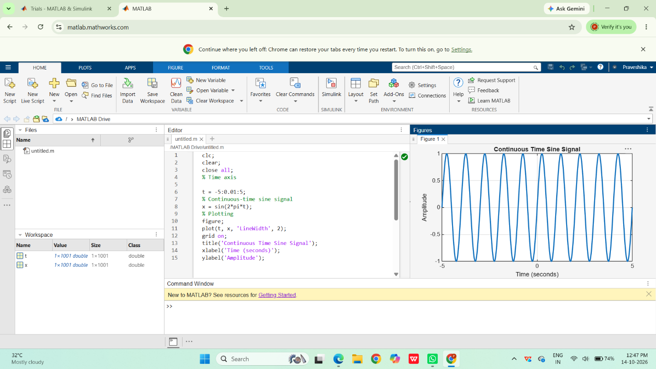

Result:
This test case validates that the signal generator can produce a sinusoidal waveform with the
specified frequency, amplitude, and phase shift.

1.2

Aim:
To generate and verify a discrete-time unit impulse signal using MATLAB. The Aim is to ensure that the signal generator can accurately produce an impulse signal at a specified timeindex, which is crucial for analyzing and understanding the behavior of discrete-time systems.

Program
clc;
clear;
close all;
% Discrete-time index
n = -10:10;
% Discrete-time sinusoidal signal
x = sin(0.2*pi*n);
% Plotting
figure;
stem(n, x, 'filled');
grid on;
title('Discrete Time Sinusoidal Signal');
xlabel('Sample Index (n)');
ylabel('Amplitude');
output waveform
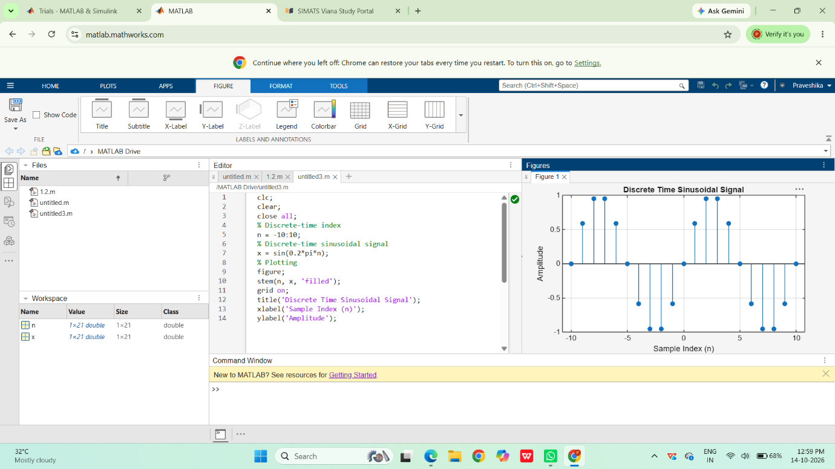
Result:
This test case validates that the signal generator can accurately produce a discrete-time unitimpulse signal at a specified index, which is essential for analyzing the response of discrete-time systems.

1.3
Aim
Generate and plot triangular and sawtooth signals.
Program
clc;
clear;
close all;
% Time axis
t = 0:0.01:2;
% Sawtooth Signal
x1 = sawtooth(2*pi*t);
% Triangular Signal
x2 = sawtooth(2*pi*t,0.5);
% Plotting
figure;
subplot(2,1,1);
plot(t,x1,'LineWidth',2);
grid on;
title('Sawtooth Signal');
xlabel('Time (s)');
ylabel('Amplitude');
subplot(2,1,2);
plot(t,x2,'LineWidth',2);
grid on;
title('Triangular Signal');
xlabel('Time (s)');
ylabel('Amplitude');

Output Generated Graph
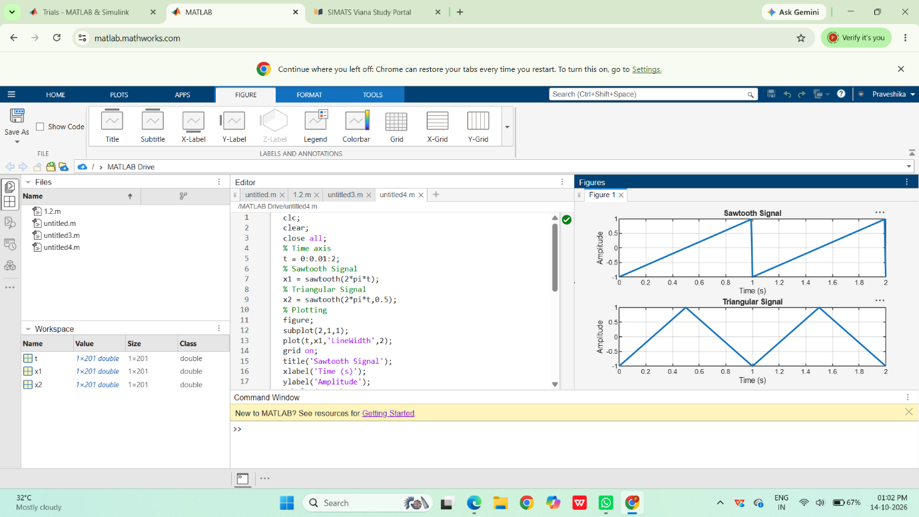
Result
Triangular wave has equal rise and fall; sawtooth shows sharp drop and gradual rise.

1.4
Aim
Generate and plot unit impulse, unit step, and ramp functions.
Program
clc;
clear;
close all;
%% Continuous-Time Signals
t = -5:0.01:5;
% Continuous Unit Step Function
u = double(t >= 0);
% Continuous Ramp Function
r = t .* (t >= 0);
%% Discrete-Time Signals
n = -5:5;
% Discrete Unit Step Function
ud = double(n >= 0);
% Discrete Ramp Function
rd = n .* (n >= 0);
%% Plotting
figure;
subplot(2,2,1);
plot(t,u,'LineWidth',2);
grid on;
title('Continuous Unit Step Function');
xlabel('Time (t)');
ylabel('Amplitude');
subplot(2,2,2);
plot(t,r,'LineWidth',2);
grid on;
title('Continuous Ramp Function');
xlabel('Time (t)');
ylabel('Amplitude');
subplot(2,2,3);
stem(n,ud,'filled');
grid on;
title('Discrete Unit Step Function');
xlabel('Sample Index (n)');
ylabel('Amplitude');
subplot(2,2,4);
stem(n,rd,'filled');
grid on;
outputwaveform
